**Digital Infrastructure and Education in Rural South Africa: A Focus on Nkandla and Ntuzuma**

1. **Current State of Digital Infrastructure in Rural South Africa**  
   The digital infrastructure in rural South Africa, particularly in areas like Nkandla and Ntuzuma in KwaZulu-Natal (KZN), is severely underdeveloped. These areas face significant challenges, including:

* Limited Connectivity: Rural areas often rely on mobile networks for internet access, but coverage is inconsistent, and data costs are prohibitively high. The digital economy in South Africa is expanding, yet rural connectivity lags behind due to the lack of investment in remote areas (U.S. Department of Commerce, 2023). The 2022 spectrum auction aimed to improve connectivity in underserved rural areas, yet challenges in deployment persist (Association of Communications and Technology, 2022).
* Lack of Electricity: Many households in rural areas lack access to reliable electricity, a prerequisite for digital infrastructure. Without electricity, even basic digital tools like computers and smartphones cannot be used effectively (Van Greunen et al., 2022).
* Digital Divide: The gap between urban and rural areas in terms of access to digital devices and digital literacy skills is significant. Rural schools, in particular, face challenges such as poor infrastructure, lack of qualified teachers, and insufficient teaching materials. For example, UNICEF (2021) notes that rural schools often lack basic resources like textbooks and computers, which are essential for digital learning.

The South African government’s SA Connect initiative aims to expand broadband access, but progress has been slow. NGOs and private sector players, such as Project Isizwe, have stepped in to provide free Wi-Fi hotspots in underserved areas. However, these efforts are not yet widespread enough to address the needs of all rural communities (Association of Communications and Technology, 2022).

1. **Low-Bandwidth Educational Solutions**  
   Globally, several low-bandwidth educational solutions have been developed to address connectivity challenges in rural areas. These solutions are particularly relevant for rural schools in Nkandla and Ntuzuma, where internet access is limited or non-existent. Key examples include:

* Kolibri: Developed by Learning Equality (2022), Kolibri is an offline-first platform that provides access to educational content without requiring internet connectivity.
* Rumie: The Rumie Initiative (2022) provides low-cost tablets preloaded with educational content for offline use.
* Zero-Rating Educational Content: Zero-rating, where educational content is provided without data charges, has been proposed as a solution for low-income areas (McBurnie et al., 2020).
* Low-Bandwidth Teaching Models: The Low-Bandwidth Teaching and Learning Initiative (LDTI) highlights the importance of designing educational content that requires minimal bandwidth. For example, text-based materials and compressed multimedia files can be used to deliver lessons in low-connectivity environments. Platforms like EdTech Hub emphasise the use of asynchronous learning tools, such as pre-recorded lessons and downloadable resources, to reduce reliance on real-time internet access.
* Offline Learning Management Systems (LMS): Offline LMS platforms, such as Moodle and Open edX, allow students to download course materials and complete assignments without needing constant internet access. These systems can sync data when connectivity is available, making them ideal for rural areas (S4YE, 2021).
* Optimising Apps for Low-Bandwidth Environments: Strategies for optimising apps in low-bandwidth environments often involve reducing data usage through techniques like data compression, caching, and minimising the use of high-bandwidth features like videos. Such methods are increasingly critical in rural areas with limited connectivity.

1. **Local Educational Requirements and Curriculum Needs**  
   South Africa’s Curriculum and Assessment Policy Statement (CAPS) outlines the educational requirements for primary and secondary schools. However, rural schools face significant challenges in meeting these requirements:

* Resource Shortages: According to UNICEF (2021), many rural schools are dilapidated, with broken desks and windows, inadequate sanitation, and unsafe learning environments.
* Language Barriers: isiZulu is the primary language spoken in Nkandla and Ntuzuma, yet most digital content is available only in English. This limits accessibility for students who are not fluent in English (UNICEF, 2021).
* Teacher Training: Many teachers in rural areas are not trained to use digital tools effectively, which limits the adoption of technology in classrooms. From Policy to Practice highlights the need for ongoing professional development programmes to equip teachers with the skills needed to integrate technology into their teaching practices.

1. **Available Technologies for Low-Connectivity Environments**  
   Technologies designed to operate in low-connectivity environments can effectively support rural schools.

* Preloaded Devices: Tablets or laptops with preloaded educational content can be distributed to schools (Rumie Initiative, 2022).
* Local Servers: Solutions like RACHEL by World Possible allow schools to host educational resources that can be accessed via Wi-Fi without needing an internet connection (World Possible, 2022).
* WhatsApp: The South African Department of Basic Education has already used WhatsApp for learning during the COVID-19 pandemic. According to Van Greunen et al. (2022), WhatsApp is particularly useful in low-connectivity environments because it requires minimal data and is widely accessible.

1. **Challenges in Implementing Digital Solutions**  
   Despite the availability of low-bandwidth solutions, several challenges persist in rural areas like Nkandla and Ntuzuma:

* Affordability: The cost of devices and data plans remains a significant barrier for many rural households (Van Greunen et al., 2022).
* Infrastructure: Inadequate electricity and internet infrastructure in rural areas hinder the implementation of digital solutions. According to UNICEF (2021), many rural schools lack basic infrastructure like electricity and running water, making it difficult to implement digital learning solutions.

1. **Recommendations for Bridging the Digital Divide**

* To address these challenges, the following recommendations are proposed:
* State Investment: The government should invest in the ICT sector to drive digital transformation in rural areas (U.S. Department of Commerce, 2023).
* Teacher Training: Skills development programs for teachers should be initiated to ensure they have the necessary skills to utilize modern technology effectively (From Policy to Practice, 2021).
* Community Engagement: Partnerships with NGOs and private sector players can help provide free or low-cost digital solutions to rural schools (Project Isizwe, 2023).

Conclusion

The digital landscape in rural South Africa, particularly in areas like Nkandla and Ntuzuma, is characterised by significant challenges, including limited connectivity, lack of infrastructure, and low digital literacy. However, low-bandwidth educational solutions and localised content can help bridge the digital divide. By investing in infrastructure, providing teacher training, and fostering community engagement, South Africa can work towards ensuring that all students, regardless of their location, have access to quality education.

**Digital Context Map Nkandla and Ntuzuma**

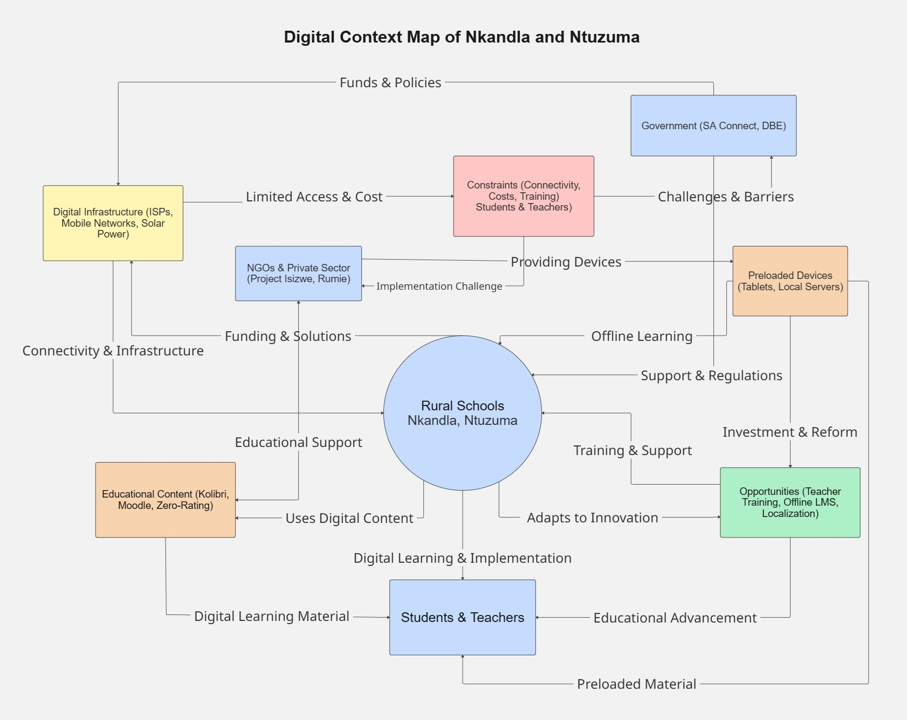

Architecture Model

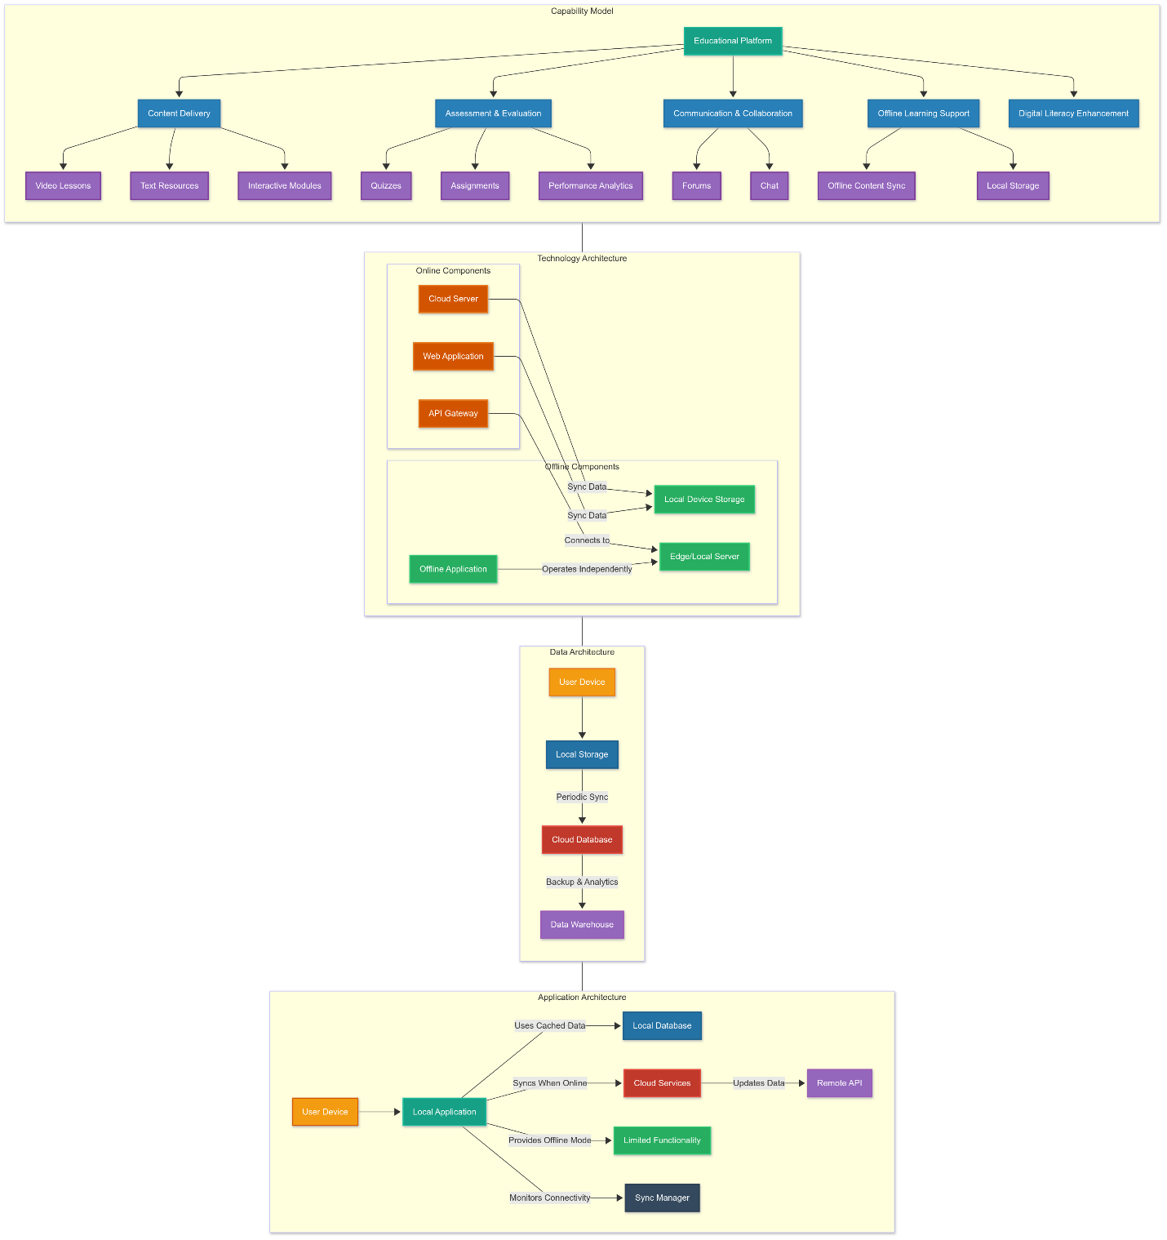

**Comic Strip Summary: "Bridging the Digital Divide: A Digital Leap in Nkandla and Ntuzuma"**

This comic strip showcases the daily struggles and victories in overcoming the digital divide in the rural areas of Nkandla and Ntuzuma, South Africa. It follows Thabo, a 12-year-old student, who battles with poor internet and limited access to digital tools, reflecting the wider problem of digital exclusion in rural education. The story highlights how local and government efforts are changing the game in digital access for education.

**Characters and Their Roles:**

1. **Thabo**: The main character, a rural student whose experiences with connectivity issues shed light on the digital challenges many learners in remote areas face. Thabo’s transformation from facing barriers to accessing digital learning tools shows the core of the narrative.
2. **Ms. Zama**: A community teacher who sees the value of digital education and fights for its reach to every student. She supports and teaches students like Thabo, helping them to navigate and benefit from new digital resources.
3. **Joe**: The local technician whose skills in setting up and maintaining digital infrastructure are key. Joe sets up community Wi-Fi zones that support low-data solutions, crucial for the students’ daily learning needs.
4. **Mr Nzimande**: A government representative who champions digital literacy and better infrastructure. His role highlights the government's support for tech advancements in education.

**Story Flow:** The comic starts with Thabo’s regular difficulties with internet access, introducing the need for better digital services in education. With the push from community leaders and government supporters like Mr Nzimande, Joe brings in practical tech solutions like community Wi-Fi and the Kolibri platform, which works offline. The story ends on a hopeful note with Thabo and his mates stepping into a new world of opportunities through improved digital access, marking a significant step towards inclusive education in rural South Africa.

This strip not only points out the challenges faced by students in outlying areas but also celebrates the joint efforts to make sure every child gets to quality education through digital means.

[Comic strip attached]

**Reference List**

Association of Communications and Technology (2022). *African Digital and Communications Ecosystem*. Available at: <https://www.stateofthenation.gov.za/assets/downloads/ov-conf/african-digital-and-communications-ecosystem.pdf> [Accessed 20 March 2025].

Learning Equality (2022). *Kolibri: Offline Educational Platform*. Available at: <https://learningequality.org/kolibri/> [Accessed 20 March 2025].

Low-Bandwidth Teaching and Learning Initiative (2022). *Low-Bandwidth Teaching and Learning*. Available at: https://lddi.educ.ubc.ca/low-bandwidth-teaching-and-learning/ [Accessed 20 March 2025].

McBurnie, C., Adam, T., & Kaye, T. (2020). *Zero-rating educational content in low- and middle-income countries*. EdTech Hub. Available at: <https://docs.opendeved.net/lib/4W3D35BT/download/3NBMJTSW/McBurnie%20et%20al_2020_Zero-rating%20educational%20content%20in%20low-%20and%20middle-income%20countries.pdf> [Accessed 20 March 2025].

Rumie Initiative (2022). *Rumie: Low-Cost Educational Tablets*. Available at: <https://www.rumie.org/> [Accessed 20 March 2025].

S4YE (2021). *Online Learning Models for Low Bandwidth Areas*. Available at: <https://www.s4ye.org/sites/default/files/2021-04/S4YE%20Brief%20Online%20Learning%20Models%20for%20Low%20Bandwidth%20Areas%20.pdf>

[Accessed 20 March 2025].

U.S. Department of Commerce (2023). *South Africa Digital Economy*. Available at: <https://www.trade.gov/country-commercial-guides/south-africa-digital-economy> [Accessed 20 March 2025].

UNICEF (2021). *South Africa National Curriculum Framework for Children from Birth to Four*. Available at: <https://www.unicef.org/southafrica/media/911/file/saf-national-curriculum-framework-0-4-en.pdf> [Accessed 20 March 2025].

Van Greunen, D., Venter, I., Craffert, L., Veldsman, A., Candi, M., & Sigurdarson, H. T. (2022). *Diagnosis of the Digital Landscape in South Africa – Skills, Infrastructure, and Available Technologies*. Common Good First. Available at: <https://project.commongoodfirst.com/wp-content/uploads/2019/11/2.2-Report-on-Digital-Landscape-in-South-Africa.pdf> [Accessed 20 March 2025].

World Possible (2022). *RACHEL – Remote Area Community Hotspot for Education and Learning*. Available at: <https://racheloffline.org/> [Accessed 20 March 2025].